12th EUROPEAN UNIVERSITIES TENNIS CHAMPIONSHIP

BULLETIN

PODGORICA, MONTENEGRO
JULY, 21-28 2019

MONTENEGRO
Montenegro - the pearl of the Mediterranean, unique in many ways, is situated in the south of the Adriatic. There is nowhere else that you can find, in such a small place, so much natural wealth, beauty, mild beaches, clear lakes, fast rivers and gorgeous mountains – like you can in the small country of Montenegro. In the morning you can wake up along the beautiful Adriatic coast, have lunch on the banks of Skadar Lake, and enjoy the evening walks in the Montenegrin Mountains. Montenegro is a place that cannot leave you indifferent.

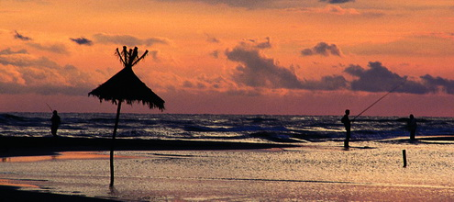

Montenegro is not only an excellent choice for your holidays, Montenegro has many other remarkable characteristics: history, culture, tradition, good weather conditions, clean air, beautiful nature, blue Adriatic Sea ... Everyone should visit Montenegro sometime. This little country is part of the Balkans and part of the Mediterranean, near Serbia, Bosnia, Croatia, Italy and Albania. Despite its small size there are so many contrasts and so much natural beauty. Don't forget to take your camera because in Montenegro every view is like a photo from your dreams. You don't even need to stage your photos; just click and you can put the most beautiful photos from your holidays in your album.

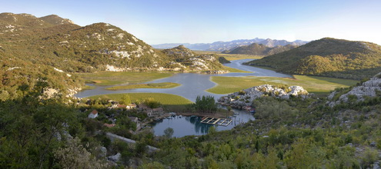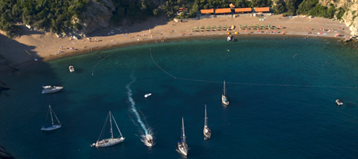

Montenegro is certainly one of the most interesting spots in the world. Even though it covers solely around 14.000 km2 and it only has about 670.000 citizens, its contribution to the world cultural heritage is impressive comparing its size ... Montenegro is a southern European and a Mediterranean country. It is one of the most southern European states and it comes out on the south part of the Adriatic Sea. About 500km from Rome, 1.500 km from Paris, and Berlin, and about 2.000km west from Moscow, Montenegro lies on the Balkan Peninsula in the very heart of Europe.

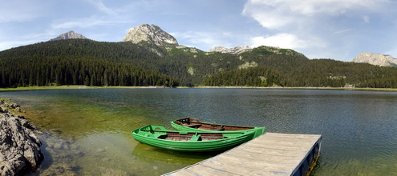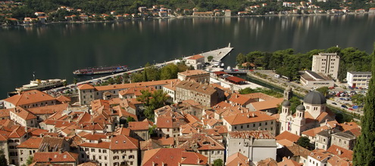

Montenegro is recognized as a country of youth and sport. The best proof for this is the numerous successes of our athletes on many competitions, while the Universities of Montenegro with its 17000 students represents an inexhaustible source of sport potential and first-class athletes.

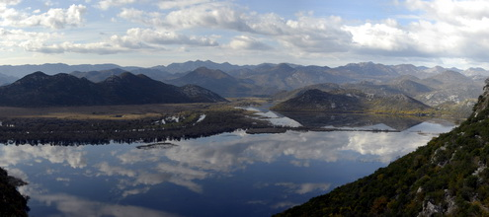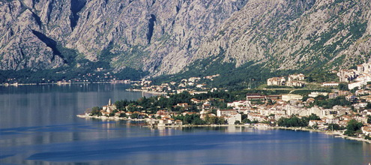

In its long and rich history, Montenegro always knew how to recognize the true values, which are not just the material ones, but include also the maturity and skills for building the way towards integrations on the lasting and universal principle of openness and perseverance as an old European country.

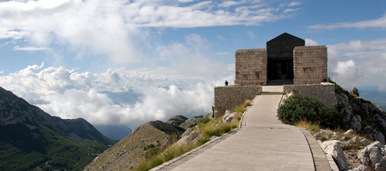

Some useful information during your stay in Montenegro:
- mother language- Montenegrin
- Time zone - GMT+1
- Electrical force system - 220V/50Hz
- Currency - Money in use in Montenegro is EURO
1EUR=100 cents
Coin: 1, 2, 5, 10, 20, 50 cents, and 1, 2 EUR
Paper currency: 5, 10, 20, 50, 100, 200 and 500 EUR
- Phone codes
Incoming international code for Montenegro is +382. City codes are:
- Bar and Ulcinj (0)30
- Podgorica and Kolasin (0)20
- Niksic and Savnik (0)40
- Cetinje (0)41
- Pljevlja and Zabljak (0)52
- Tivat and Kotor (0)32
- Berane, Rozaje and Plav (0)51
- Herceg Novi (0)31
- Bijelo polje and Mojkovac (0)50
- Budva (0)33

When calling from Montenegro to your country - country code + city code

- Cellular telephony
- Mobile bands: GSM 900, GSM 1800, HSDPA, HSUPA, UMTS
- There are three operators in Montenegro:
T-mobile | code: (0)67 | Info: 1500
M:tel Montenegro | code: (0)68 | Info: 1600
Telenor Montenegro | code: (0)69 | Info: 1188
Their roaming services are available in all European countries and in bigger countries throughout the world. Tourists are recommended to use prepaid cards which can be bought a Post Offices, operator’s selling services and kiosks.
- Important phone numbers:
Police | 122
Fire station | 123
Emergency squad | 124
Exact time | 125

PODGORICA
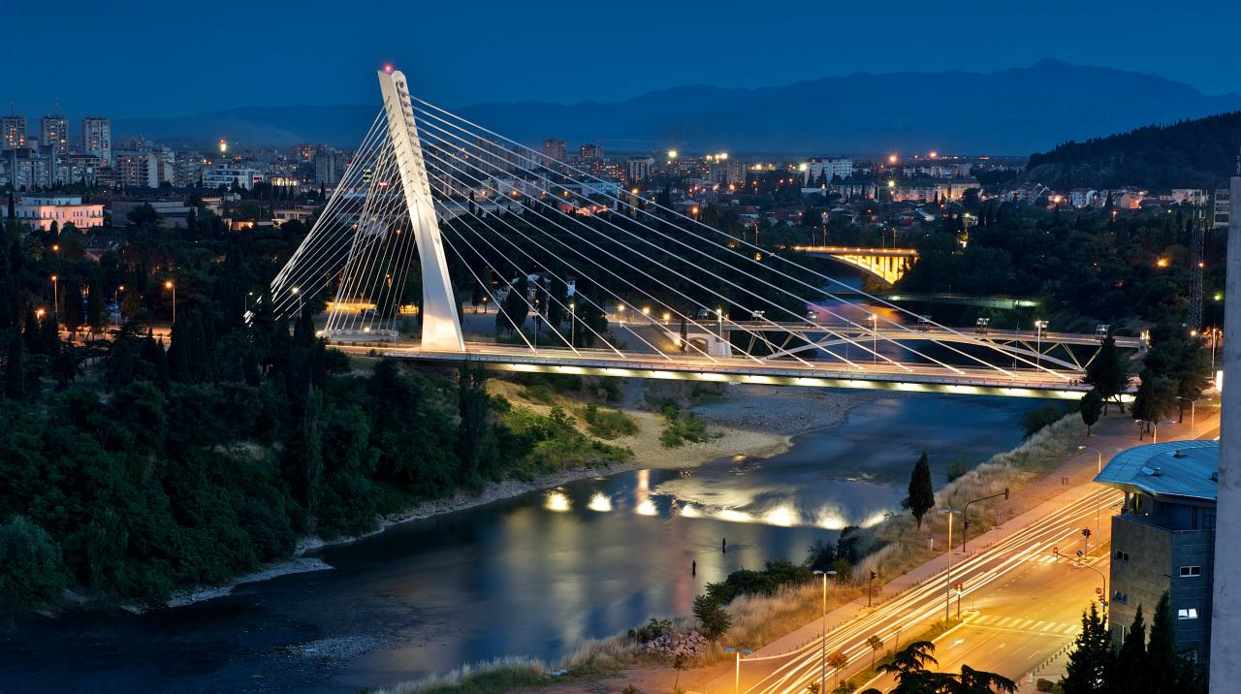
Podgorica is the capital and largest city of Montenegro. The wider area of Podgorica contains 10.4% of Montenegro territory and about 30% of its population. Podgorica is the main crossroad in Montenegro, and it is near the ski resorts in the north of the country and seaside resort on the Adriatic Sea.
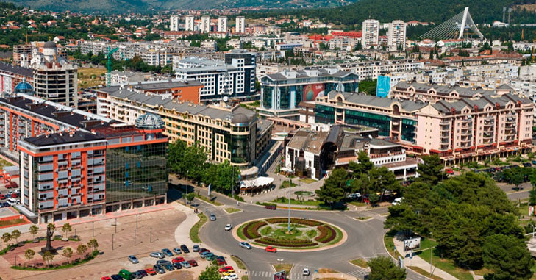
Fertile Zeta plain, composition of the Zeta and Ribnica rivers with Moraca River, proximity to the Skadar Lake and Adriatic Sea, favourable climate, communicative and strategic position, made it possible for Podgorica to grow into the largest urban centre of Montenegro. It is not just urban city, but the city that is the administrative, political, economic, scientific, educational and cultural centre of Montenegro.
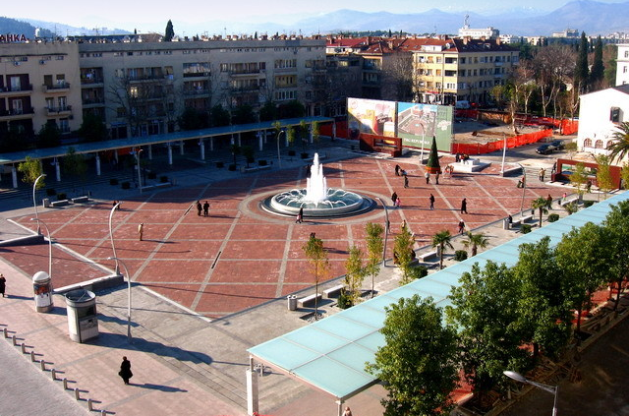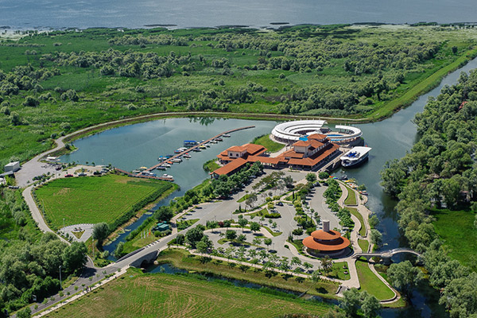
Podgorica is connected by a highway, just 54 kilometres long, which leads to the Montenegrin coast, and 70 kilometres north is the first ski resort. Montenegrin main international airport Golubovci (Podgorica) is 6 kilometres away from the city centre and is associated with national and international airports.
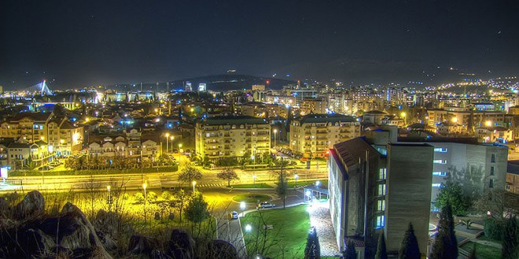
The city itself is known by spacious and nicely aranged green surface and parks. In some of them the pine tree dominates and in the others there are more deciduous trees such as linden, oak and plane trees. In the last period the boulevards in Podgorica are spreaded and they are decorated with the atractive trees – palms. Along the main city roads there are bushy vegetation like boxwood.

Rivers are therefore the sources of life. Rivers Morača, Ribnica, Zeta, Sitnica, Mareza and Cijevna have determined the city borders for ages, but also a great number of subterranean waters make this area rich of a healthy drinking water. Limestone beds and extraordinary relief sculptured by Podgorica waters, apart from the practical, give Podgorica ecological aesthetic appearance.
Podgorica is made of the areas characteristic by their geography. In the area of Kuči and Piperi, agricultural production and cattle-breeding dominate the fruit growing, while mountain patato in this area thrive extremely well. Here, fishponds could be found in which the excellent trout is bred.
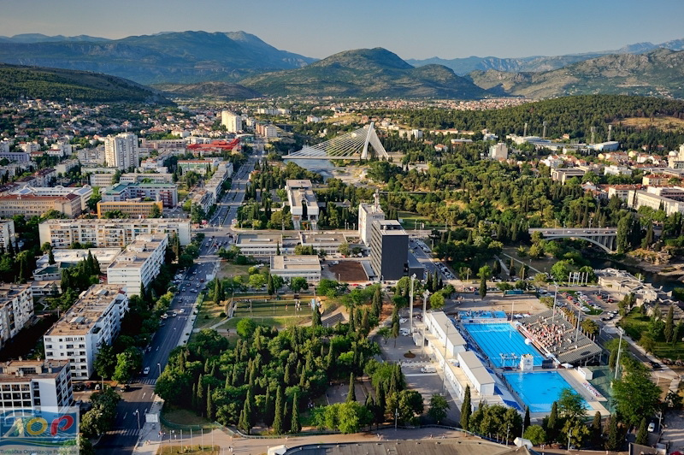
The Adriatic Sea makes an influence on the climate of Podgorica, along the vale of River Bojana, through the Lake of Scadar. Under the influence of surrounding mountains, Mediterranean climate is changing, so that Podgorica has Mediterranean – changed climate, which is characterized by warm and hot summers and mild and rainy winters. Thanks to the thermo influence of the Adriatic Sea, Podgorica has quite high winter temperature.

STUDENTS SPORTS ASSOCIATION OF MONTENEGRO
The Ministry of Education and sports and The Sport and youth Directorate identity the Students sport Association of Montenegro as the National Sports Federation, a fully member of the Montenegrin Olympic Committee and also as a member of the European and World Universities Sports Associaitons (EUSA,FISU).

Although it has been founded in 1979, the Students Sport Association of Montenegro has reached the height of success only after the Montenegrin independence declaration and the UN acknowledgement, main condition for being admitted by EUSA (2006) and FISU (2007). In August 2007,our waterpolo players won the first place at the Universiade held in Bangkok, Thailand. This has been the first and the really meaningfull result in team sports fro the country of Montenegro.

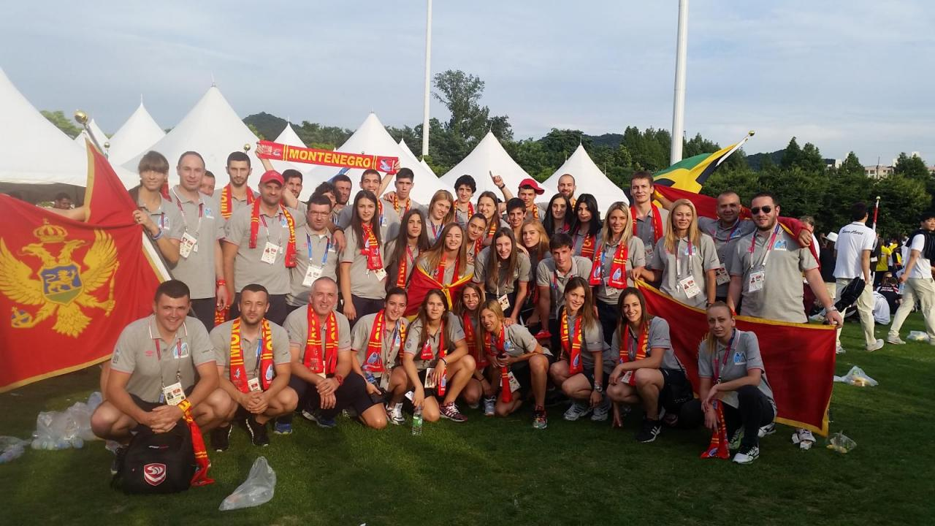

We cover four types of International championship in almost every sport:
- Universiade (summer and winter edition)
- World University Championships
- European Universities Championships
- EUSA Games
Since 2007, we took part in
- six Universiades (Bangkok, Thailand, 2007; Belgrade, Serbia, 2009; Erzurum, Turkey, 2011; Shenzen, China, 2011, Kazan, Russia, 2013, Gwangju, Korea);
- ten World University Championships: in karate (Wroclaw, Poland, 2008; Podgorica, Montenegro, 2010; Bratislava, Slovakia, 2012; Bar, Montenegro, 2014; Braga, Portugal, 2016), in futsal (Koper, Slovenia, 2008; Novi Sad, Serbia, 2010); in savate (Nantes, France, 2010); in archery (Tainan, Chinese Taipei, 2008); in taekwondo (Belgrade, Serbia, 2008);
- twelve European Universities Championships: in karate (Podgorica, Montenegro, 2007; Vigo, Spain, 2009; Sarajevo, Bosnia and Herzegovina, 2011; Budapest, Hungary, 2013; Zabljak, Montenegro, 2015); in futsal (Wroclaw, Poland, 2008; Podgorica, Montenegro, 2009); in volleyball (Rijeka, Croatia, 2007); in tennis (Moscow, Russia, 2008; Dublin, Ireland, 2009; Bar, Montenegro, 2013); table tennis (Nis, Serbia, 2009)
- three edition of EUSA games (Cordoba, Spain, 2012; Roterdam, Netherlands, 2014; Zagreb & Rijeka, Croatia 2016)
Our most important international successes are:
- first place in 2007 (waterpolo) at Summer Universiade in Bangkok, Thailand
- five 1st places in 2007 at the European Universities Championship (karate, Podgorica, Montenegro)
- two 3rd places in 2008 at the WUC karate, Wroclaw, Poland
- two 5th places (men and women team) in 2007 at EUC volleyball, Rijeka, Croatia
- 4th place in 2008 at EUC futsal, Wroclaw, Poland
- 5th place in 2008 at WUC taekwondo, Belgrade, Serbia
- 5th place in 2009 at EUC futsal, Podgorica, Montenegro
- 1st place in 2009 at EUC karate (kata team women), Vigo, Spain
- two 2nd places in 2009 at EUC karate, kumite, Vigo, Spain
- two 2nd places in 2010 at WUC karate, Podgorica, Montenegro
- two 3rd places in 2010 at WUC karate, Podgorica, Montenegro
- two 1st places, five 2nd places, and five 3rd places in 2011 at EUC karate, Sarajevo, Bosnia and Herzegovina
- one 1st place, two 2nd places and two 3rd places in 2012 at WUC karate, Bratislava, Slovakia
- two 1st places, three 2nd places, five 3rd places in 2013at EUC karate, Budapest,Hungary
- 3rd place in 2013 at EUC tennis (women), Bar, Montenegro
- one 1st place and three 3rd places in 2014, at WUC karate, Bar, Montenegro
- 1st place in Regional University basketball league 2014 (University of Montenegro)
- 4th place at Universiade Gwangju 2015, High jump women
- 5 medals on European Universities karate championship 2015 (three gold, and two bronze)
- 1 st place on WUC karate 2016 in Braga, Portugal, kumite +84kg
- 5 medals on EUSA games 2016 (karate – one silver, one bronze, judo – one silver, one bronze, taekwondo – one bronze)
- Award for best University in Judo on EUSA games 2016 – University Donja Gorica

Really meaningful part of our labor are the national competitions. Students sport Association of Montenegro organizes competitions for all the Montenegrin students in athletics, skiing, beach-volleyball, tennis, karate, cross country, table tennis, chess, street ball, swimming. There are also leagues in team sports - futsal, basketball, volleyball, handball, basketball 3x3 and mini football.

We organize competitions for sports which are most attract students. In wide range of our activities, there are also scientific meetings, sports and recreational activities on the snow, the election of the best student-athlete, non-competitive motivational sports activities (hiking, biking, archery, golf, kayaking, dance, fitness, trainings in nature...), etc.]

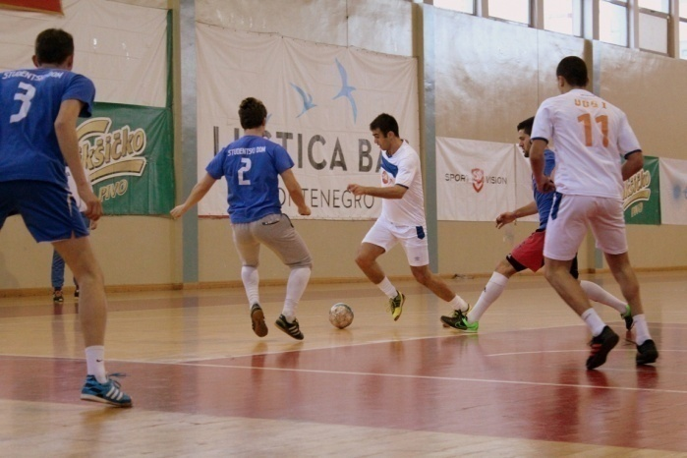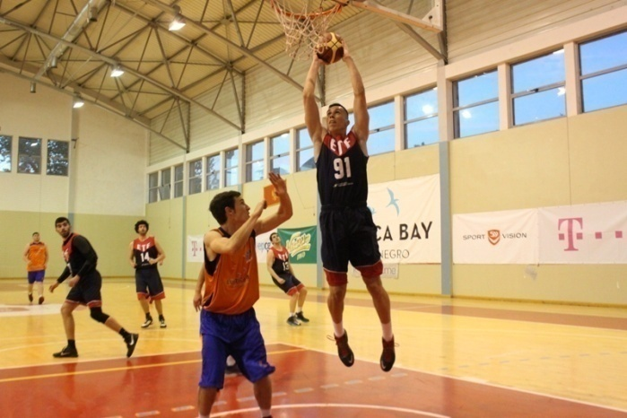

The National University Championships not only put together a great number of competitors, but also raise interest in those who are not competing but like to keep up to date with our events. Our website www.unisport.me and the Facebook page Studentski sportski savez are visited by a great number of competitors who collect information about scores, announcement of competitions...

We are proud to say that students taking part in our championships don't have to pay. The SSAM pays all the costs, and for what concerns the leagues, we also pay the sports equipments and travel fees.

International Championships organized by SSAM
No | date | sport | name of competition | level of the competition | Location
1. | July 2003 | karate | 1st European Universities karate Championship | European University Championship | Podgorica, Montenegro
2. | July 2007 | karate | 3rd European Universities karate Championship | European University Championship | Podgorica, Montenegro
3. | July 2009 | futsal | 6th European Universities futsal Championship | European University Championship | Podgorica, Montenegro
4. | July 2010 | karate | 7th World University karate Championship | World University Championship | Podgorica, Montenegro
5. | September 2013 | tennis | 9th European Universities tennis Championship | European University Championship | Bar, Montenegro
6. | June 2014 | karate | 9th World University karate Championship | World University Championship | Bar, Montenegro
7. | July 2015 | karate | 7th European Universities karate Championship | European University Championship | Zabljak, Montenegro

UNIVERSITY OF DONJA GORICA
UDG mission is to create conditions for studying upon principles of high quality European education. That it is possible to achieve shows several generations of graduates who have successfully continued their master's and doctoral studies in the West or are already very successful in companies and institutions where they found employment soon after graduation. A number of them, with the help of UDG opened private companies during their studies, and many are considering to do so.
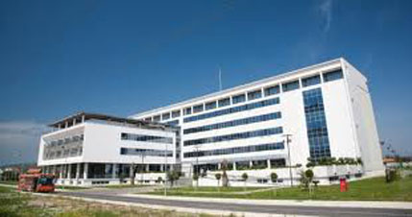
One of the important advantages of UDG is that it is developing multidisciplinarity. Of course, the fact that they are in a modern building, all together, students of ten undergraduate study programs, about 25 postgraduate and 3 PhD programs, or close to 2,000 students, allows the synergistic friction of various occupations and professions. Many foreign teachers and managers praise studing at UDG because they are not massive studies. Indeed, studies are oriented to the student as an individual, a student whose character we are building through individual communication and group work. In addition to investments in fundamental technical knowledge, much is invested in skills of students. UDG strive to have students that will have the knowledge of 2-3, maybe even four foreign languages upon graduation, which is provided through prestigious school of languages. UDG is probably one of the few universities that invests heavily in general education, literature and culture of the students, entertainment, sports, travel and art events.
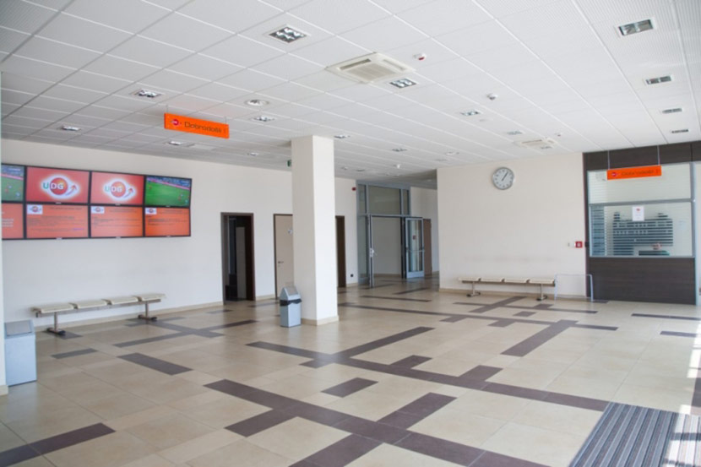
Students have the opportunity earn pocket money during their studies, then to attend international summer schools, summer internships in Europe, USA, Africa and Asia. Students are also provided with: Center for career councelling, rhetorical sections, Debate Club, recitation sections, choir Polihimnija, Presentations: variety of new educational and technological secrets UDG have support from Montenegrin largest companies, as we have dozens of signed cooperation agreements with businesses in Montenegro and the region. We also have agreements with universities in most countries of the region, Europe and several universities from the United States, Canada and South America. Teachers from all continents teach at UDG. We are members of a several international university associations: Assosiation of Private Enterprise Education based in the U.S., World University Council based in Ankara and Central Eastern Europe Regional University Alliance. We have close cooperation with some large international foundations, such as Atlas Foundation, Liberty Fund, American Enterprise Institute.
UDG Marathon, traditionally took place at 4th April, day of students. Start and the finish line was in front of the University of Donja Gorica. Participation on V UDG Marathon was massive. It was 478 participants, which is around 300 students more than year before.
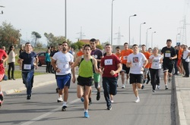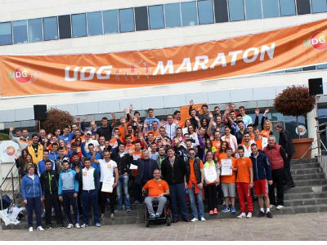
UDG is delighted to hear compliments from many of our guests who take part in our forums, round tables, exhibitions in our gallery. It’s especially pleased by support of Mr. Jose Manuel Barroso, President of the Government of the EU (the European Commission), who was a guest at UDG, which is the only university in the region that he visited.
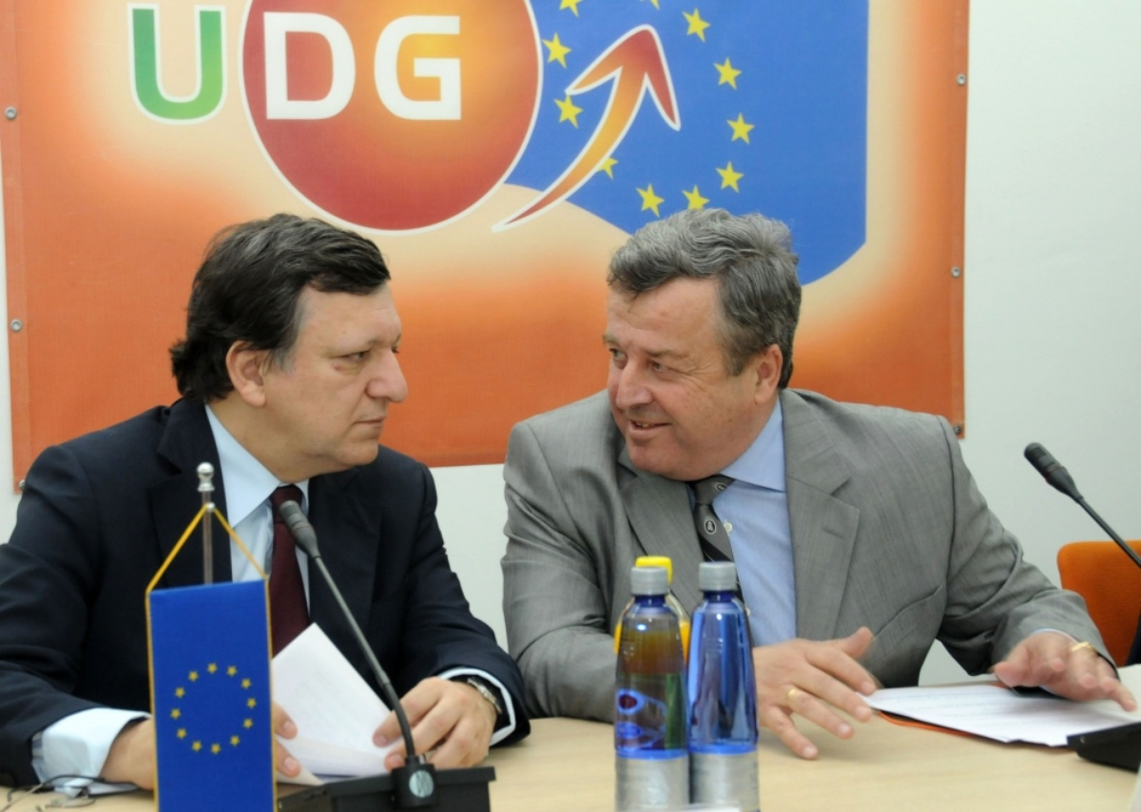
As it regards classes, they are organized in state-of-the-art technological environment, in the building that allows the creation and enjoyment of students in a real university atmosphere, an atmosphere that builds positive energy and wakes the ambition of all. UDG have developed special financial programs to facilitate entry at UDG. UDG hope that this year will be canceled dumping prices on the education market in Montenegro. UDG have provided a number of scholarships from companies and the government of Montenegro which is a "customer" of fifty places for students at the Faculty of Polytechnic, Faculty of Food Technology, Food Safety and Ecology, Informatics and Security, studies that are not represented at the state University of Montenegro. From this academic year we are developing special programs and special solutions for gifted and talented high school students and their preparations for future postgraduate and doctoral studies. In addition to gaining knowledge and skills, as insisted upon by the new EU strategy document "Rethinking Education in the EU", UDG focused on the development of competencies of our student, that is on developing his motivation, set of values, attitudes towards life.
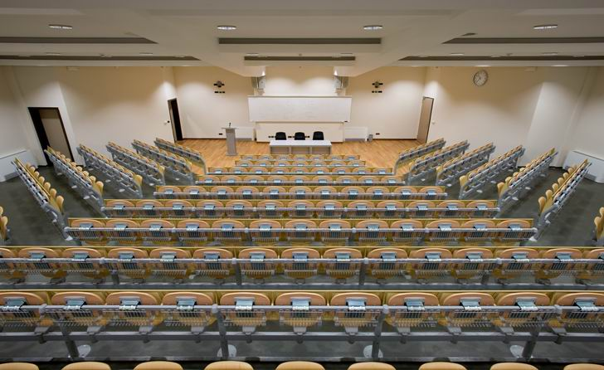
- Faculty of International Economics, Finance and Business
Faculties at UDG:
- Faculty of International Economics, Finance and Business
- Faculty of Information Systems and Technologies
- Polytechnics
- Faculty of Law
- Humanistic studies
- Faculty of Arts - Faculty for Sports Management - Faculty of Philology - Faculty for Culture and Tourism - Faculty of Psychology
- Faculty for Food Technology, Food Safety and Ecology - Faculty of Design and Multimedia
- UDG Centre for Foreign Languages

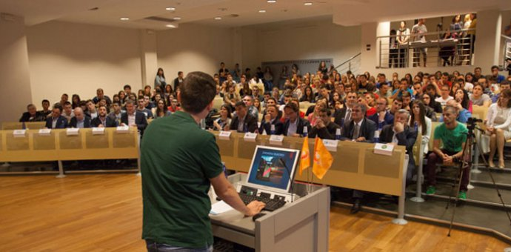

UDG offers:
- Quality studying environment (newly built space of about 16,000 m2 in the final stage of construction).
- State of the art equipment
- Compliance with international standards in the construction, equipping of buildings and teaching.
- Young teaching staff, with extensive participation of professors from outside of Montenegro Interdisciplinary Studies (students have the ability to combine courses from different faculties).
- The University is going to be organized as a campus-creating conditions for day long stay of students at the University, with the construction of residential houses and dormitories in the near future.
- Strong emphasis on sports activities of students, which are part of courses, as well as on the physical development of students.
- The practice of students is part of the studying process at UDG.
- Students are provided with opportunity to communicate with people from the business world from the region and the world.
- Incubator for business-helping students to develop their business ideas during studies and support to start their own businesses.

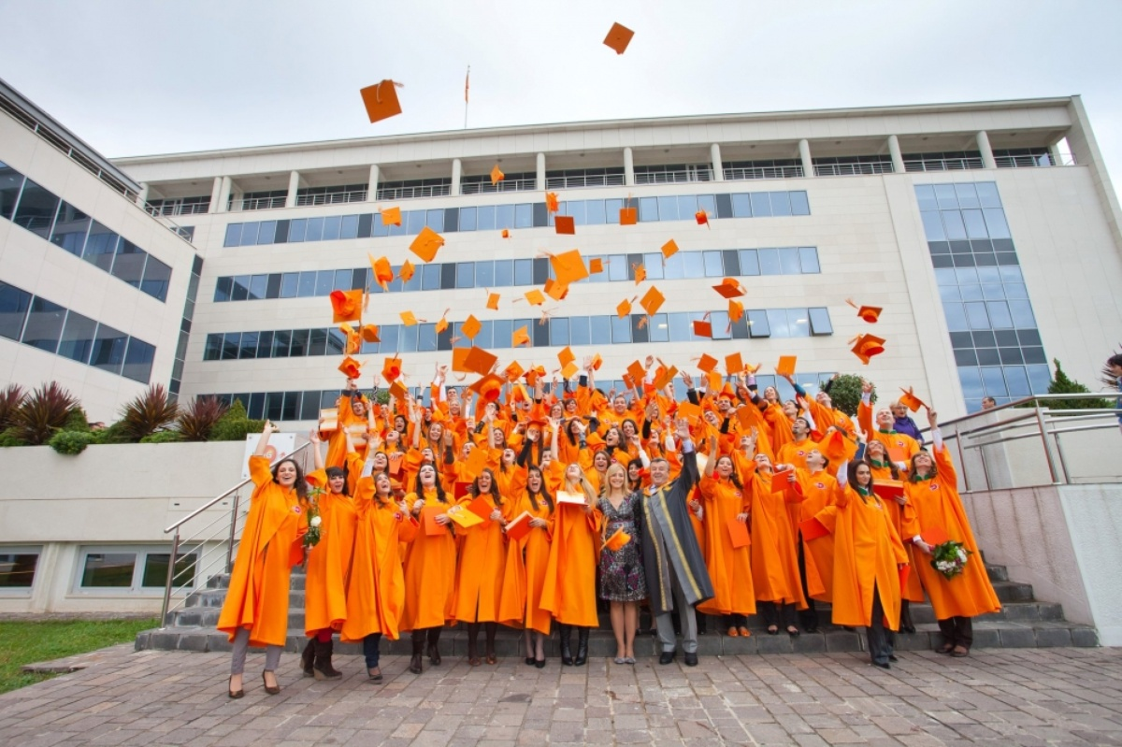
ORGANIZING COMMITTEE
- Boris Sekulic, Students Sports Association of Montenegro president, Organizing Committee president
- Prof PhD Veselin Vukotic, University Donja Gorica rector
- Miodrag Asanovic, Tennis club As president
- Mr Ivan Jovetic, University Donja Gorica, Head for sports
- Predrag Zecevic, Students Sports Association of Montenegro EC president
- Biserka Radulovic , Students Sports Association of Montenegro sports manager

OC KEY PERSON CONTACT:
Name Boris
Surname Sekulic
Phone +382 20 265 942
Mobile +382 67 510 611
e-mail office@unisport.me, sekulic.boris@yahoo.com , bisa.r@ t-com.me
Fax +382 20 265 942

OC STRUCTURE
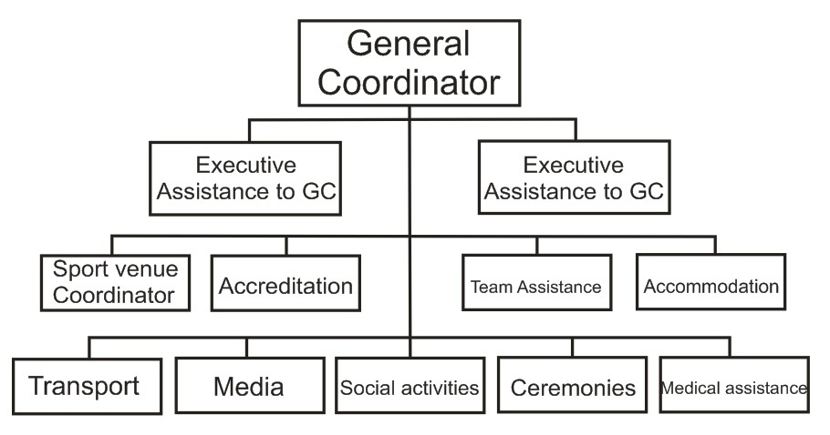
COMPETITION SCHEDULE

July 21th Arrivals, SCAC meeting
July 22th Arrivals, General technical meeting, Opening ceremony
July 23th Group stage matches
July 24th Group stage matches
July 25th Quarter finals
July 26th Semi – finals
July 27st Finals, Closing ceremony
July 28nd Departures

COMPETITION AND TRAINING VENUES –

TENNIS CLUB AS - http://www.tkas.me/
Tennis club "AS Podgorica" ​​was founded more than a decade and a half, when he disposed with only one field and small restaurant in its immediate vicinity. Thanks to the hard work, effort and material resources that are constantly invested in this club, today's "AS Podgorica" ​​has grown into a modern tennis center that meets all standards and requirements for how best to play tennis recreationally and professionally.
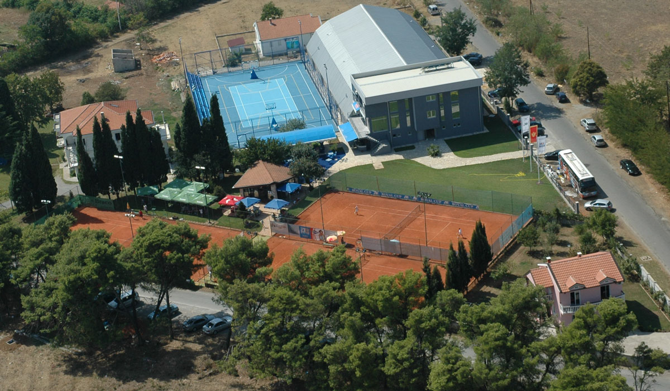
Today, the Club has four outdoor courts with clay, and one field with a silicone base that is Isogen composition as a basis on which to play Australian Open, and three more indoor courts (clay) can be used also. As part of this tennis center there is Sports hall in which there are two courts of special carpets made of synthetic sports surfaces. In addition to the hall, the club also has four suites, a gym, a restaurant, open bar, clinic, office space, locker rooms and showers, etc. In a word, it's officially the best club in Montenegro, which in recent years has been the backbone of the DAVIS (male) and FED CUP (female) representation. One of the constant offer of the club is renowned brands Babolat tennis equipment.
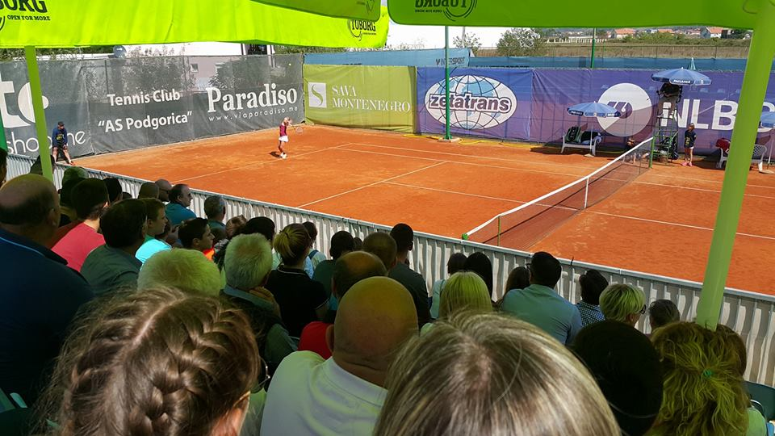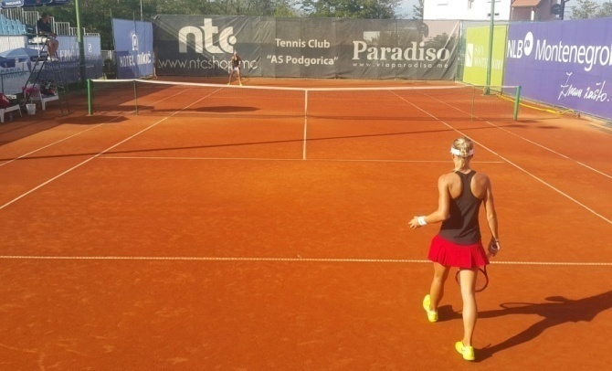
In order to complete deals, the club also offers repair and stringing racquets, tennis ordering the widest variety of equipment and software for their own tennis courts.
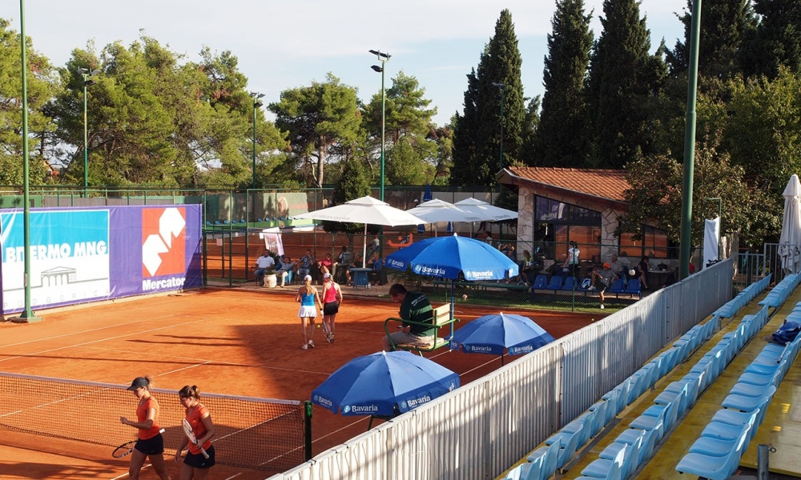
Since 2004 Tennis club As Podgorica is a host of the Royal Cup NLB Montenegro tennis tournament for female tennis players. In first ten editions this event was classified as a $50,000 ITF Women’s Circuit tournament, while from 2013 it is classified as $25,000.
The most famous player which is member of the tennis club is the best Montenegrin female player Danka Kovinic, which is now on 72nd place on WTA list.
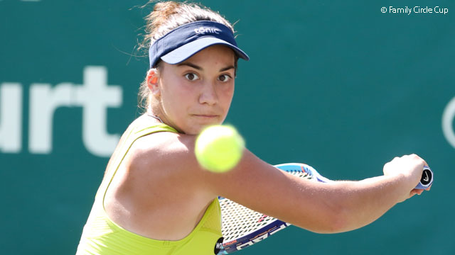

TENNIS CLUB EMINENT- https://www.tkeminent.me/

Tennis club Eminent was founded 2009. It is set on the location Velje brdo near the old road Podgorica- Danilovgrad , just 5 km away from Vezirov bridge towards the Spuz. Beautiful environmentnear coast Zeta provides total tennis enjoyment .
The accent is both on competition and recreational playing tennis, where through specific relation with tennis lovers, both children and grown ups develops high consciousness about importance of tennis and by that a club as a lifestyle.
Tennis club Eminent has been holding tournaments for years on international level such as ITF tournaments which are junior international tournaments for the age up to 18 ( the strongest tournaments for that age ) as well as two ETA tournaments which on annual basis gather more than 500 tennis players both male and female from all over the world .
Also our club holds around 15 lokal tournaments on annual basis in categories to 10,12,14 and 16 years.

Tennis club currently owns :
6 open terrain tennis courts (all courts are by ITF standars) , locker rooms , gym, new ballon with 2 tennis courts (for playing in the winter season) , restaurant …

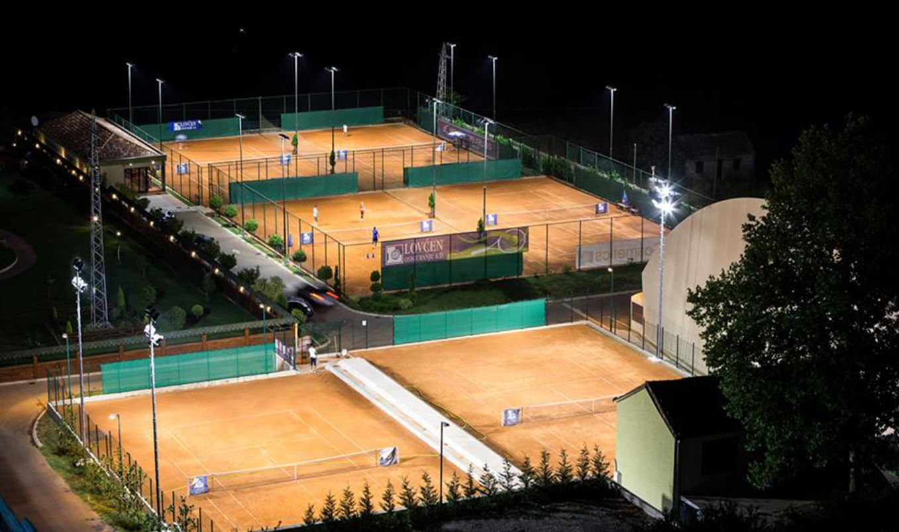

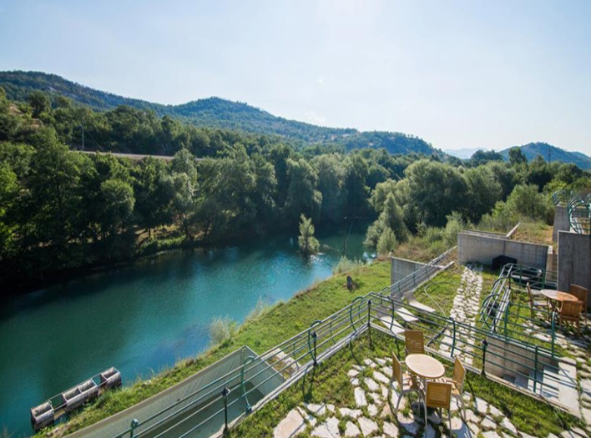 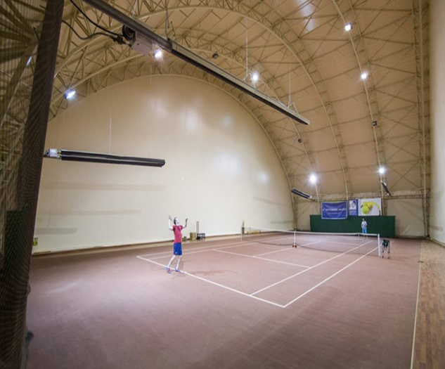 https://www.tkeminent.me/galerija

ACCOMMODATION – TEAMS
NEW STUDENTS DORMITORY - http://www.novistudentskidompg.me/
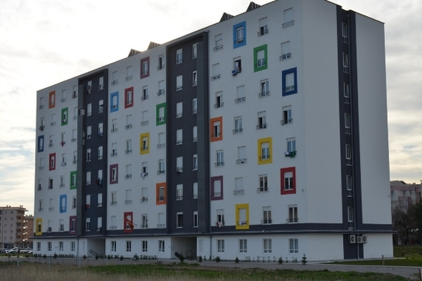
The new facility – Students dormitory, built in 2012/2013 according to the latest global and environmental standards, and students use it from academic 2013/2014 year.
The building comprises a basement, ground floor and six floors, gross area of 7,630 m², of which the surface of the overhead part of 6,690 m². The building has 126 double and 70 triple rooms with a total capacity of 462 seats. The double rooms on the ground floor and the first floor is envisaged 12 places for people with special needs.
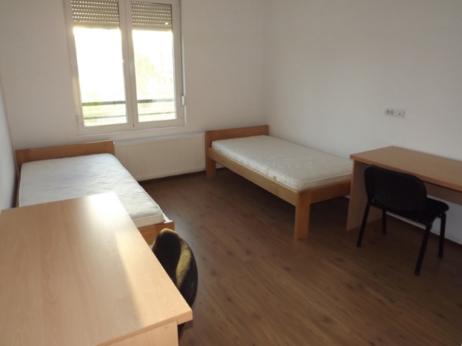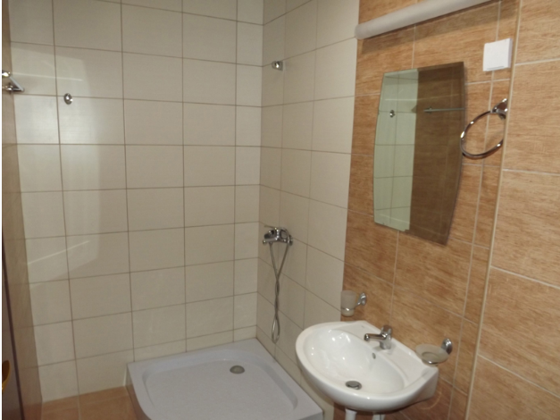
In addition to accommodation, the building has the following facilities: reception, office space for administration, technical rooms, a library, a reading room with a capacity of 84 seats, as well as internet room with 20 places. Each room has a toilet and Internet connection, air conditioning system is common for all building, while rooms has additionally air conditioners. Laundry service is also provided in basement.
Restaurant is situated in a next building to the accommodation.
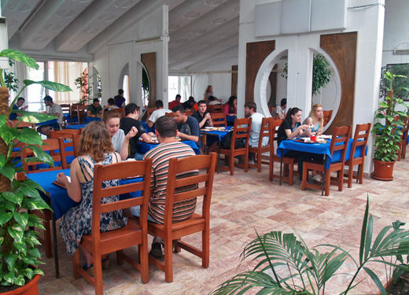
The capacity of the restaurant is 200 seats. The kitchen's daily production and serving during academic year is 3 000 - 6000 meals depending on the engagement of students.
Breakfast 07:00 – 10:00
Lunch 12:00 – 16:00
Dinner 18:00 – 21:00
Water is drinkable in a restaurant, as well as in accommodation centre.

ACCOMMODATION – EUSA
HOTEL VERDE 4*- http://verdecomplex.com/
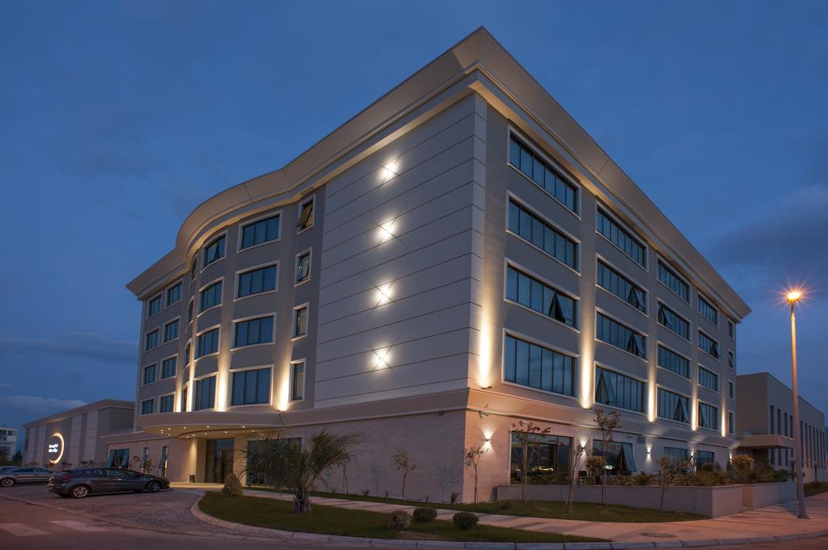
HOTEL VERDE is part of the recreation complex, located out of the city, along the river Sitnica, which determined the concept and content of the hotel, tailored to the customer needs.
Built according to international standards of construction, using materials and systems which appear to be friendly to the environment, Hotel grants the necessary comfort and peace for guests as well as a pleasant working atmosphere and services which are designed to complement and make the guest’s stay even more beautiful. The rooms are colored in tones of nature, along with modern lines of furniture.
The hotel can accommodate 174 persons in 81 accommodation units, spacious and cozy with diverse structure.
A rich gastronomy offer of the hotel is available in buffet and a la carte restaurant, along with a VIP Gallery.
The other complex facilities are intended to provide additional, more and more needed, relaxation and recreation to our guests.

VERDE COMPLEX is open for the organization of various sports, business, cultural and other events, all upon client’s request; It is ideal for professional athletes’ trainings, conference tourism, for business people, but also for beginners who simply desire to enjoy the various facilities of the Complex.

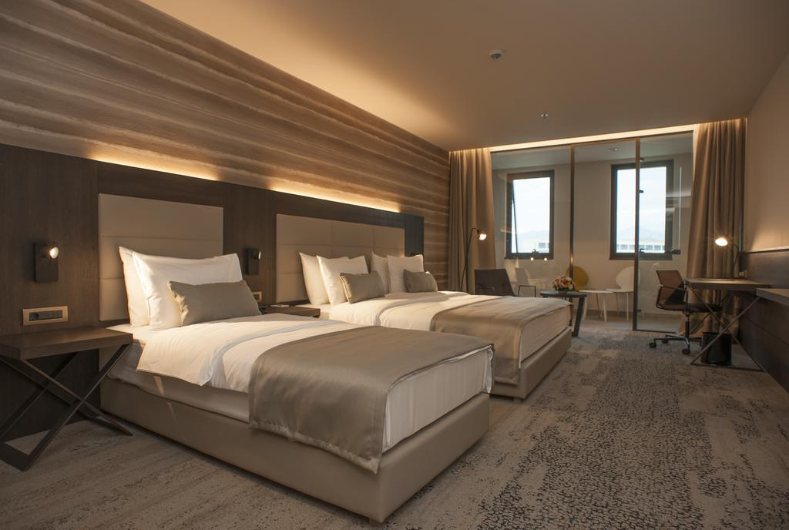

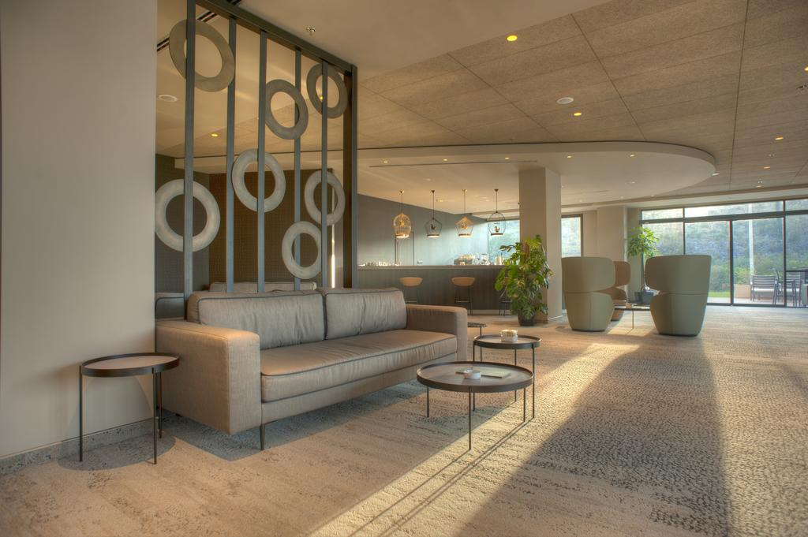

TRANSPORTATION
Arrival & Departure points:
  - Airport Podgorica (Golubovci)
  - Train station Podgorica
  - Bus Station Podgorica

Arrival dates: 20,21 July
Departure dates: 28,29 July

Distances
 | Teams accommodation | EUSA accommodation
Airport Podgorica | 13 km | 15 km
Train station | 4 km | 7 km
Bus station | 4 km | 7 km

During official training sessions and competitions shuttle bus line with sufficient number of departures, will be provided from teams accommodation to competition venues (distance is around 4 km).

PROVISIONAL BUDGET
 | Costs | €
1 | Competition and training venues, Press Center, Balls | 3.000
2 | Arrival & Departures | 2.500
3 | Shuttle bus | 3.000
4 | EUSA EC member, TDs, Medical officer | 3.500
5 | Medals and diplomas | 1.000
6 | Gifts 200 x 7euros | 1.400
7 | EUSA attribution fee | 4.000
8 | Security 10 persons x 8 days x 30 euros | 2.400
9 | Referees / accommodation 8 days x 6 x 40 euro | 1.920
10 | Volunteers 30 persons x 10 days x 10 euros | 3.000
11 | Bulletins, Accreditations, OC Office... | 5.000
12 | Cultural program/Promotion of Chanmpionship | 5.000
13 | OC and CC (ceremonies) and protocol (flags, banners ect.) | 3.000
14 | Ice and water 10.000 bottles 0.5l water X 0.35 euros | 3.500
15 | Medical care, ambulance and doctor | 3.000
16 | Accommodation of athletes 120 persons x 8 days x 30euro | 28.800
 | Total | 74.020

 | Income | €
1 | Participation fee 120 persons x 65 euro x 8 days | 62.400
2 | Sponsors | 7.000
3 | Donations | 5.000
 | Total | 74.400

